User Guidelines
Patient Guidelines
1. Login
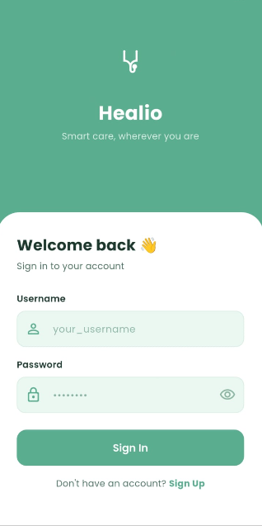
Open the Healio app. Enter your username and password and tap Sign In. If you don't have an account tap Sign Up.

2. Register
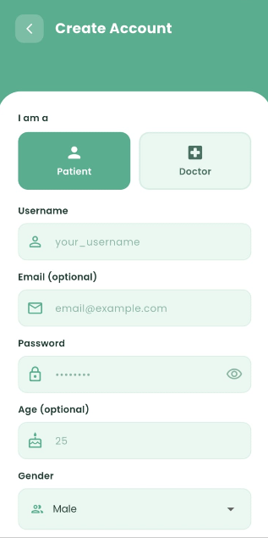
Select your role as a Patient. Fill in your username, email (optional), password, age, gender and bio. Tap Create Account.

3. Home Screen
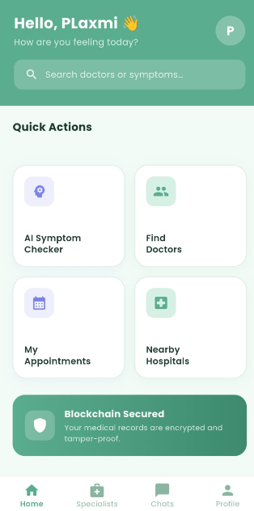

After login you will see the homepage with four quick actions: AI Symptom Checker, Find Doctors, My Appointments and Nearby Hospitals. The bottom navigation bar gives access to Specialists, Chats and Profile.

4. AI Symptom Checker
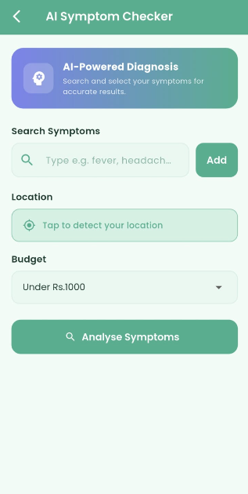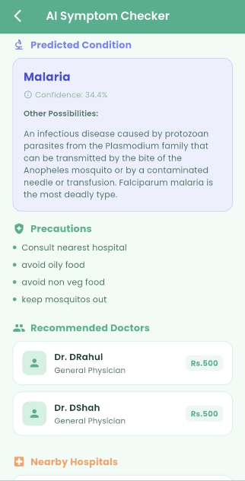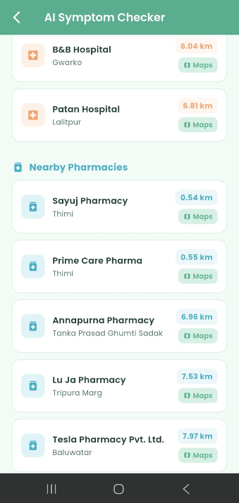
Tap AI Symptom Checker from the quick actions. Search and add at least 3 symptoms. Tap your location to detect it automatically. Select your budget and tap Analyse Symptoms. The AI predicts your condition with a confidence score, lists precautions, recommends matching doctors and shows nearby hospitals with distances.

5. Find Doctors
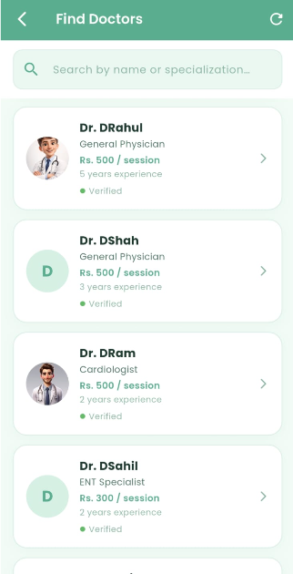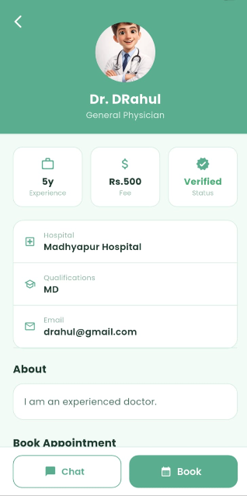
Tap Find Doctors from the home screen. All verified doctors are listed with their specialization, consultation fee and experience. Tap any doctor to view their full profile. The doctor profile shows experience, consultation fee, verification status, hospital, qualifications and bio.

6. Book Appointment
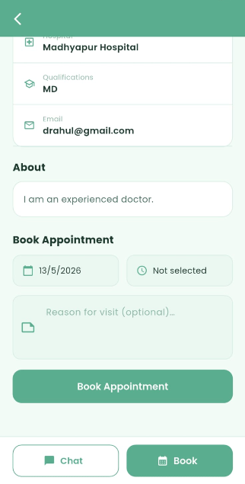
Scroll down to the doctor’s profile to the Book Appointment section. Select a date and time by tapping the date and time fields. Add an optional reason for visit. Tap Book Appointment to confirm. You can also tap Chat to message the doctor directly.

7. Booking Confirmation & Payment
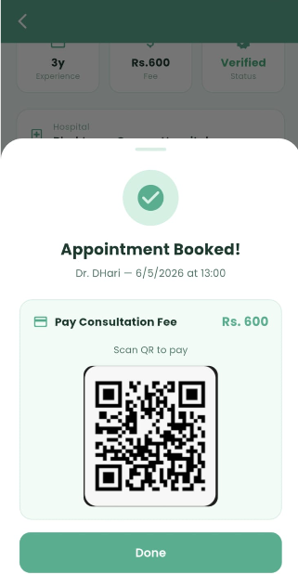
After booking, a confirmation screen appears showing the doctor’s name, date and time. The consultation fee is displayed with a QR code to scan and pay if you are planning to pay online. Tap Done to close.

8. My Appointments
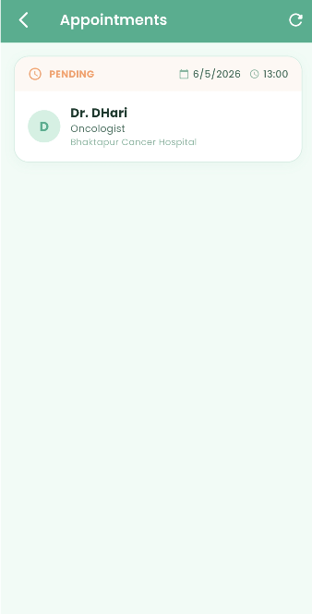
Tap My Appointments from the home screen to view all your bookings. Each appointment shows the status, date, time, doctor name, specialization and hospital.

9. Nearby Hospitals & Pharmacies
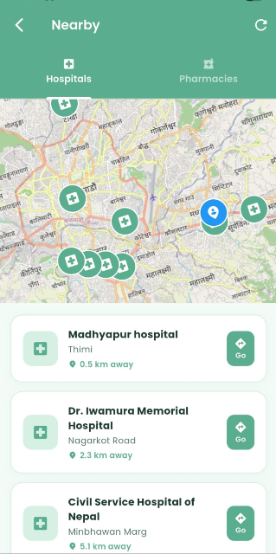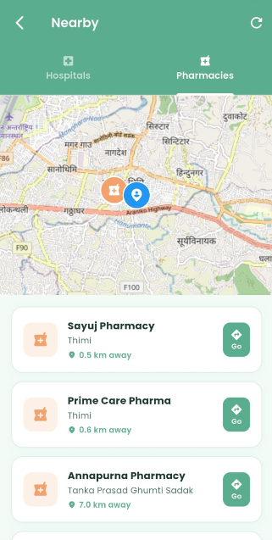
Tap Nearby Hospitals from the home screen. The map shows your location (blue pin) and nearby hospitals (green pins). Below the map, hospitals are listed by distance. Tap Go to open directions in Google Maps. Switch to the Pharmacies tab to find nearby pharmacies.

10. Messages / Chat List
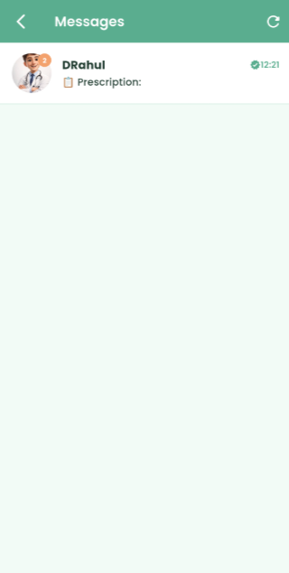
Tap Chats from the bottom navigation bar. All your conversations are listed here showing the doctor's name, profile picture, last message and time. A verified badge appears next to verified doctors. Tap any conversation to open the chat.

11. Chat Screen
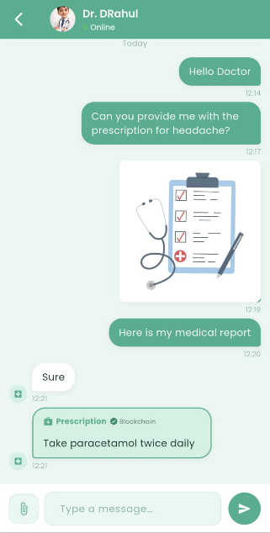
The chat screen shows real-time messages with the doctor. The doctor's online status is shown at the top. Type your message in the text box and tap the send button. Tap the paperclip icon to attach and share medical reports or images. Messages are delivered instantly via WebSocket.

12. Specialists
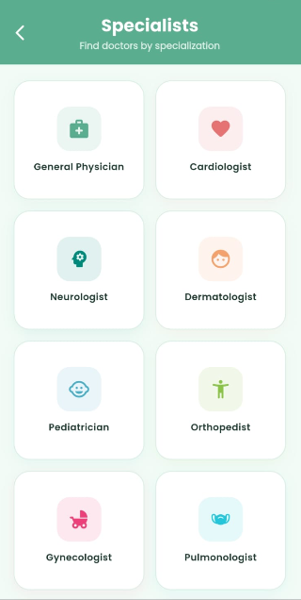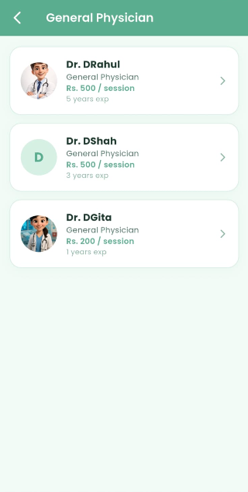
Tap Specialists from the bottom navigation bar to browse all through different medical specializations. Tap any specialization card to see all verified doctors in that category. Tap a doctor to view their profile and book an appointment.

13. My Profile
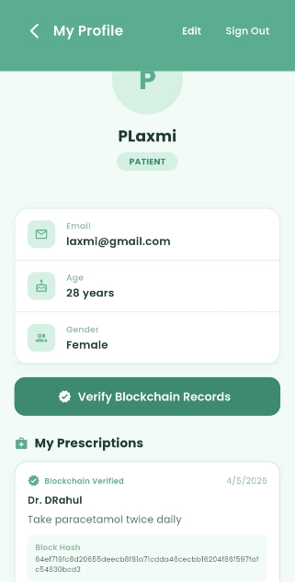
Tap Profile from the bottom navigation bar. Your profile shows your username, role, email, age and gender. Tap Edit to update your details or upload a profile picture. Tap Sign Out to log out. Your prescriptions are listed at the bottom under My Prescriptions.

14. Blockchain Verification
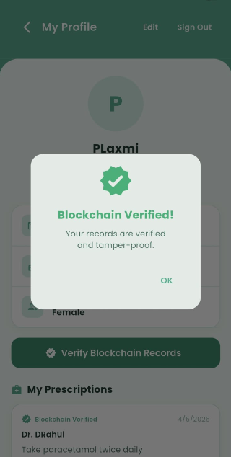
Tap Verify Blockchain Records on your profile page. The system checks the entire SHA-256 hash chain. If all records are intact a confirmation message appears as "Blockchain Verified! Your records are verified and tamper-proof." This confirms no one has tampered with your medical data.

Doctor Guidelines
1. Login
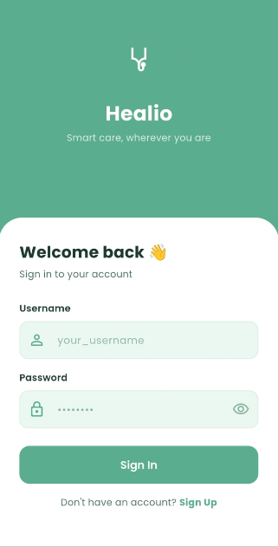
Open the Healio app. Enter your username and password and tap Sign In. If you don't have an account tap Sign Up.

2. Register as Doctor
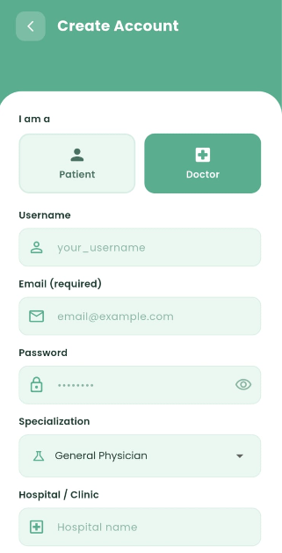
On the registration screen select Doctor. Fill in username, email (required), password, specialization, hospital, qualifications, years of experience, consultation fee and bio. Tap Create Account. Your account will be pending until the admin verifies it.

3. Home Screen
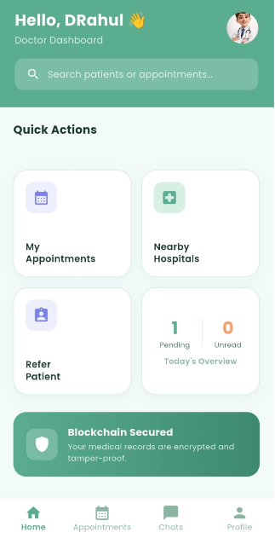
After login the Doctor Dashboard shows My Appointments, Nearby Hospitals, Refer Patient and Today's Overview showing pending appointments and unread messages. The chat icon shows unread message count.

3. Manage Appointments
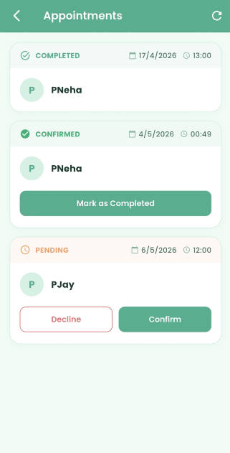
Tap My Appointments on quick actions or bottom navigation to see all patient bookings. For pending appointments tap Confirm or Decline. For confirmed appointments tap Mark as Completed.

4. Nearby Hospitals & Pharmacies
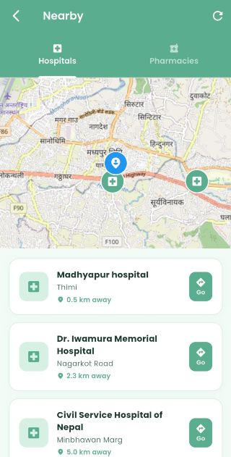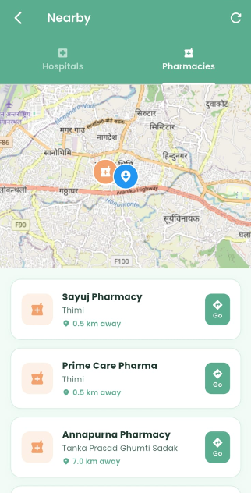
Tap Nearby Hospitals from the home screen. The map shows your location (blue pin) and nearby hospitals (green pins). Below the map, hospitals are listed by distance. Tap Go to open directions in Google Maps. Switch to the Pharmacies tab to find nearby pharmacies.

5. Refer Patient
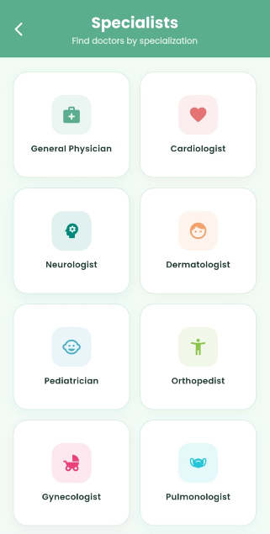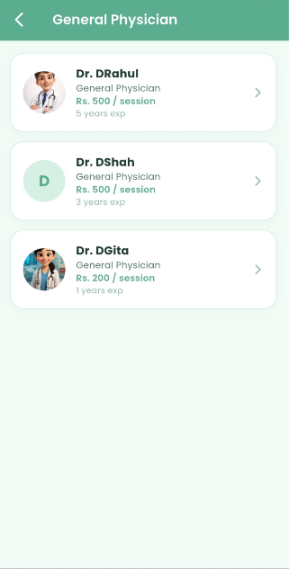
Tap Refer Patient to find doctors from different specialization find the right specialist to refer a patient to if needed.

6. Chat
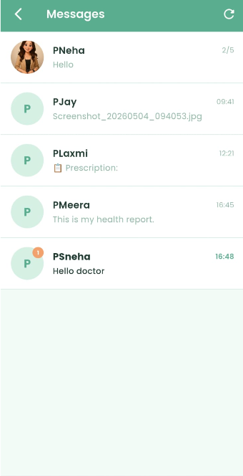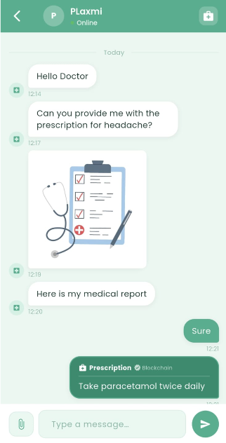
Tap Chats from the bottom navigation. All patient conversations are listed with the last message and unread count shown in orange badge.

7. Write Prescription
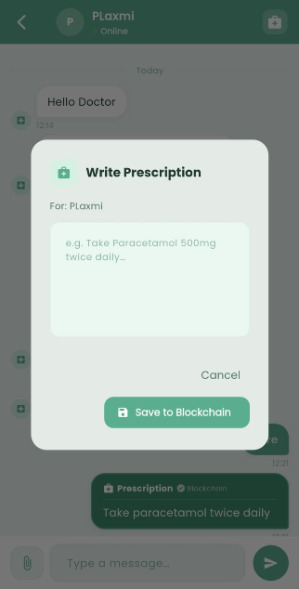
Open a patient chat and tap the prescription icon in the top right corner. A dialog appears to write the prescription for the patient. Type the prescription details and tap Save to Blockchain. The prescription is permanently stored on the blockchain and automatically sent to the patient in the chat.

8. My Profile
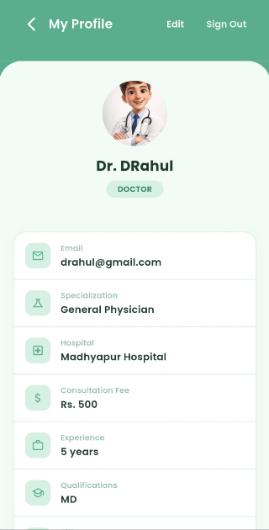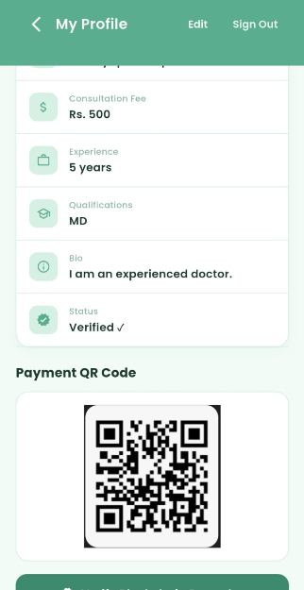
Tap Profile to view your professional details including specialization, hospital, consultation fee, experience, qualifications and verification status. You can upload your payment QR code for payment. Tap Edit to update your details. You can also upload your picture.

9. Today's Overview
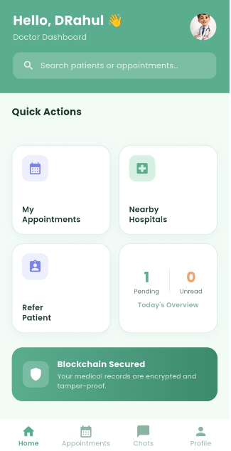
The Today's Overview card on the Doctor Dashboard shows a quick summary of number of new appointments and new messages. This updates automatically when patients book appointments or send messages.

Admin Guidelines
1. Admin Dashboard
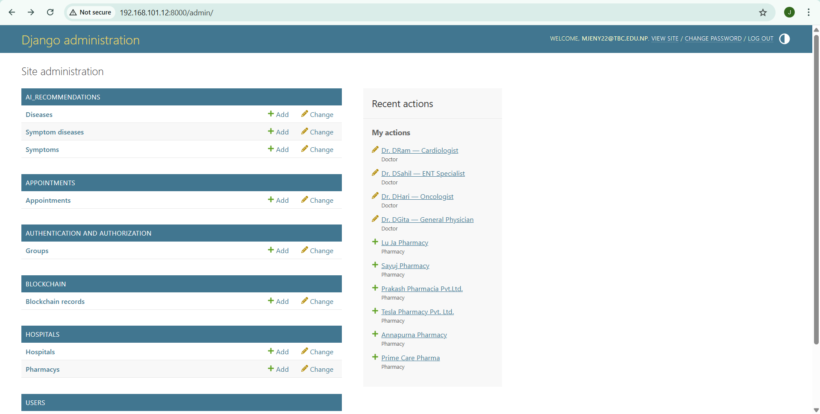
Open a browser and go to http://localhost:8000/admin. Log in with the admin credentials. The dashboard shows all sections like AI Recommendations, Appointments, Blockchain, Hospitals, Pharmacies and Users. From here the admin can manage all data in the system.

2. Doctor List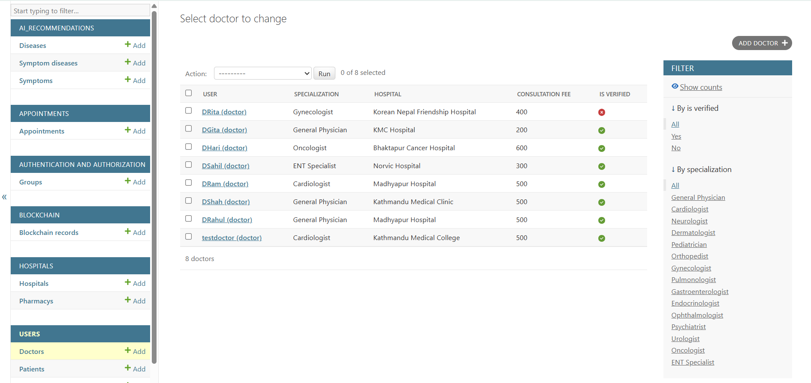Click Doctors under the USERS section. All registered doctors are listed showing their specialization, hospital, consultation fee and verification status. Green tick means verified, red cross means not yet verified.

3. Verify a Doctor
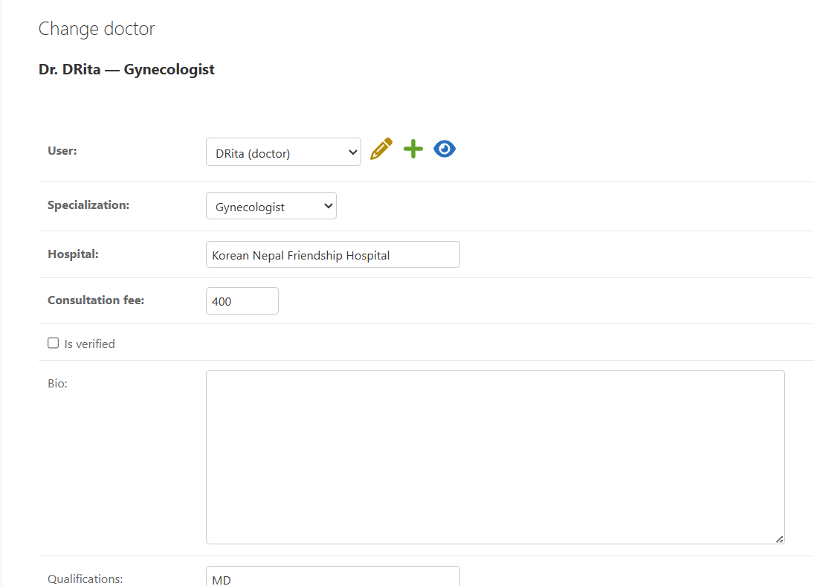

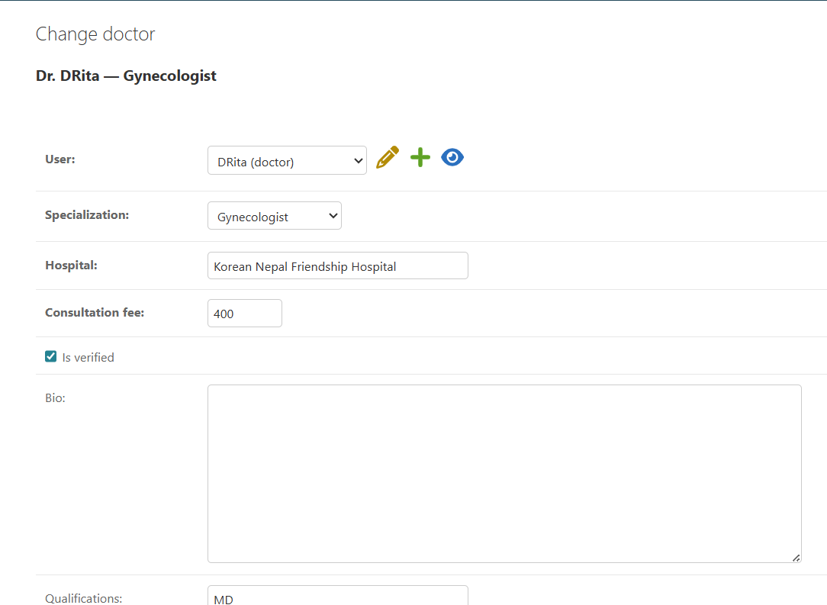

Click on any unverified doctor's name. The doctor detail page opens showing all their information. Tick the Is verified checkbox and scroll down to click Save. The doctor is now verified and will appear on the app. A blockchain record is automatically created storing the verification hash.

